|  |  |
| --- | --- |
|  | **UNIVERSITI MALAYSIA SARAWAK**  **Faculty of Computer Science and Information Technology** |

Assignment/Report Cover Sheet

|  |  |  |  |
| --- | --- | --- | --- |
| **Student Name** | **Student Id Number** | **Group** | **Signature** |
| **DANIAL BIN SHARIF** | **24030454** | **-** |  |
|  |  |  |  |
|  |  |  |  |
|  |  |  |  |

|  |  |  |  |  |
| --- | --- | --- | --- | --- |
| **Subject Code:** **TMS6124** | | **Subject Name: WEB AUTHORING** | | |
| **Assignment Title:** | **Assignment 1** | | **Lecturer:** | **Ts Dr Lim Phei Chin / Ts Nurfauza Jali** |
| **Due Date: 6 April 2025** | | | **Date Submitted: 27 Mar 2025** | |

This cover sheet must be completed, signed and firmly attached to the front of the submission. All work must be submitted by the due date. If an extension of work is granted, an assignment extension acknowledgement slip must be signed by the lecturer/tutor and attached to assignment. Please note that is your responsibility to retain copies of your assignment.

***Plagiarism and Collusion are methods of cheating that falls under Peraturan Akademik Universiti Malaysia Sarawak para 11: Etika Akademik***

**Plagiarism**

Plagiarism is the presentation of work which has been copied in whole or in part from another person’s work, or from any other source such as the internet, published books or periodicals without due acknowledgement given in the text.

**Collusion**

Collusion is the presentation of work that is the result in whole or in part of unauthorized collaboration with another person or persons.

Where there are reasonable grounds for believing that cheating has occurred, the only action that may be taken when plagiarism or collusion is detected is for the staff member not to mark the item of work and to report or refer the matter to the Dean. This may result in work being disallowed and given a fail grade or if the circumstances warrant, the matter may be referred to a committee of inquiry for investigation. Such investigation may result in the matter being referred to the University Discipline Committee, **which** has the power to exclude a student.

**MARK:**

**Upon placing signature above, I certify that I have not plagiarized the work of others or participated in unauthorized collusion when preparing this assignment.**

**I also certify that I have taken proper care in safeguarding my work and have made all reasonable efforts to ensure that my work is not able to be copied.**

|  |  |  |  |  |  |  |  |  |  |
| --- | --- | --- | --- | --- | --- | --- | --- | --- | --- |
| **ACKNOWLEDGING YOUR USE OF AI**  If you completed any work with the aid of an AI tool, assuming a setting in which the instructor gave permission for such tools to be used, you should always acknowledge the use. Using the outputs of an AI tool without proper acknowledgement is equivalent to lifting or paraphrasing a paragraph from a source without citation and attracts the same sanctions. You can give this acknowledgement through a note or “methods section” at the end of the assignment explaining, e.g., which AI tools were used, in which parts of the process they were used, what were the prompts used to generate results, and what you did with the outputs to add value.  One way this can be done is in a tabular form as shown below:   |  |  |  | | --- | --- | --- | | AI Tool used | Prompt and output | How the output was used in the assignment | |  |  |  | |  |  |  |   Alternatively, if an AI tool was used to generate a more extensive set of intermediate outputs that were then developed into a final product, you should preserve a full transcript of the relevant interactions with the AI as an appendix for submission with your assignment. Your instructor may also require you to explicitly declare if AI tools were not used in a part of your assignment, or for the whole assignment. In all cases, seek advice from your course instructor.  *Source: extracted from https://libguides.nus.edu.sg/new2nus/acadintegrity* |

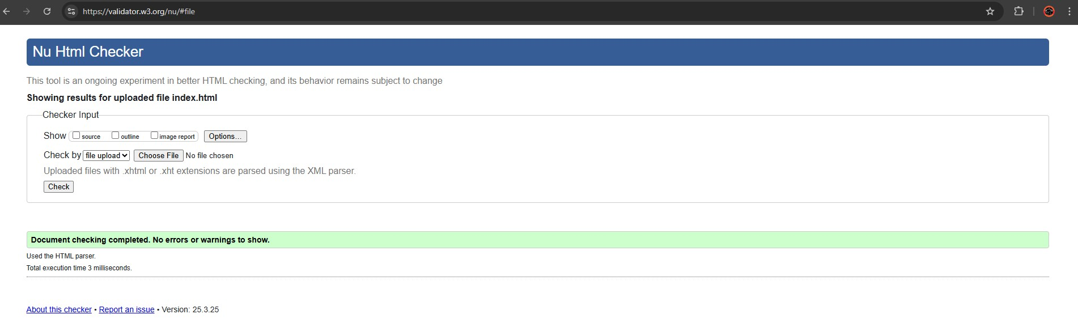

**HTML Validation Report**

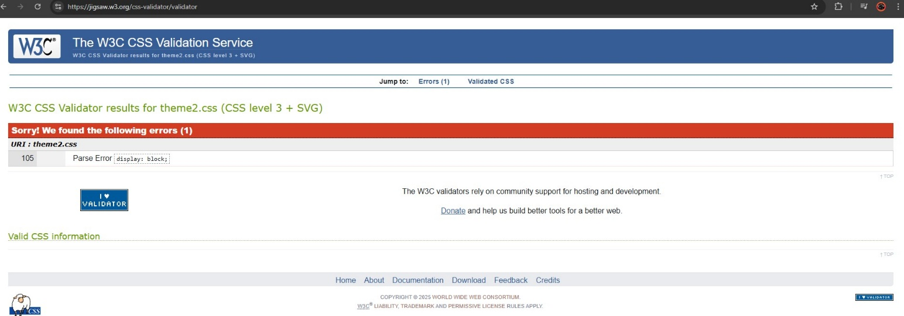

**CSS Theme 2 Validation Report**

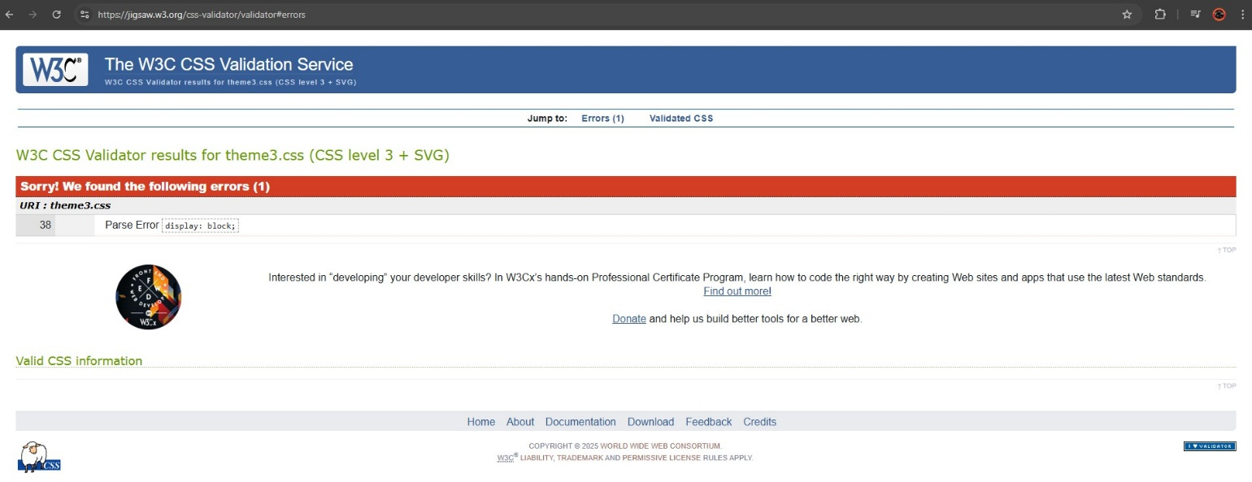

**CSS Theme 3 Validation Report**